4

Prg182 – V_AM group 2
Project – Milestone 1

Belgium Campus Itversity
Date of Submission –
Group Members: Student ID:
Alexander Kruger 605298
Jeru Dumas 606800
Micaela Schoeman 603315
Neo Modingoane 603574
Contents
Solution Idea 2
Functional requirements 2
Non-Functional requirements 2
Limitation 2
The Data Structures Used in the System 3
Flowchart 4
Flowchart Explanation 5
Structure Chart 6
Structure Chart Explanation 7
User Interaction 8
Main Menu Interaction: 8
Use Case Scenarios: 8
Case 1: Adding Income 8
Case 2: Adding Expense 8
Case 3: Viewing Transactions 9
Case 4: Viewing Monthly Report 9
Error Handling: 9
HITL 9
Future of AI in C# 10

Solution Idea
A group of university students share an apartment but struggle to keep track of their shared monthly expenses such as rent, utilities, groceries and entertainment. To solve this problem our C# program will make it easier to be transparent about individual expenses and ease the calculations of individual debts. The program will have volatile memory, meaning that all entered data is not stored.

Functional requirements
- Prompt expenses amount, small description and a (Fixed / Hardcoded) category
- Prompt Income amount, person with the income, and the source of income
- Calculate equal split of total expenses for each student living together
- Generate monthly summary report that is sorted by the category of expenses and by descending cost. Summary should also include the debt of each student to current expense pool

Non-Functional requirements
- Clear menu numbered console to guide users
- The program must give a confirmation message when adding information so that the user knows something happened ex. “added transaction”
- All calculations need to be mathematically accurate to 2 decimal places
- The program must not crash if user enters an unexpected data type
- The program must prevent negative numbers to be added

Limitation
- The program is limited to volatile memory, if the program closes the entered data won’t be saved
- The program is limited to console interface, no graphical user interface will be used

The Data Structures Used in the System
The cost-sharing system will make use of dynamic data structures to manage user and transaction information. A List < Transaction> structure will be used to store multiple expense entries that are entered by the users. Lists allow dynamic storage through transaction records during calculations. When a user enters a new expense, it will be added to the list. The list will display all transactions in a menu and is also used in calculations such as the total spending.
A Dictionary <string,double> structure will be used to store the expense categories and, in this structure, the category name plays a pivotal role while the total expense amount acts as the value. The use of these data structures helps with improving data organisation and reinforces processing efficiency in the system.

Flowchart
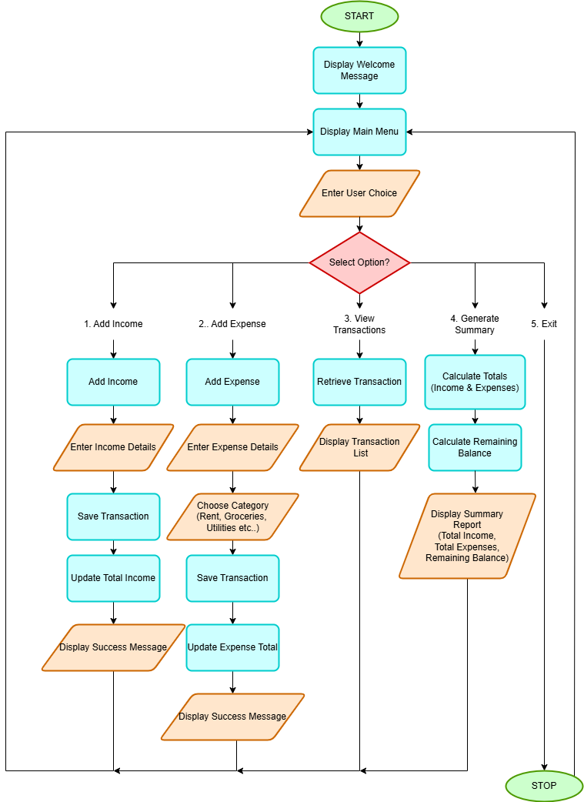

Flowchart Explanation
The flowchart illustrates the logical flow of the Budget Tracker, focusing on how a user navigates the system without requiring complex database operations.
- Main Control Loop: The program starts with a welcome message and enters a continuous loop at the Main Menu, ensuring the student users can perform multiple tasks in one session.
- Decision Logic: A central decision diamond processes the user’s choice (1-5). This implements the control structures (conditionals) required to manage program flow.
- Transaction Processing:
- Add Income/Expense: These paths detail the sequence of inputting details, updating totals, and saving the transaction to the internal data structure.
- Categorization: The "Add Expense" path specifically includes a step for choosing a category (e.g., Rent, Groceries, Utilities), addressing the shared apartment requirements.
- Summary Generation: This module outlines the logic for calculating totals and remaining balances, providing students with an immediate overview of their spending habits.
- Termination: The "Exit" path provides a clean break from the loop, leading to a terminal STOP node.

Structure Chart
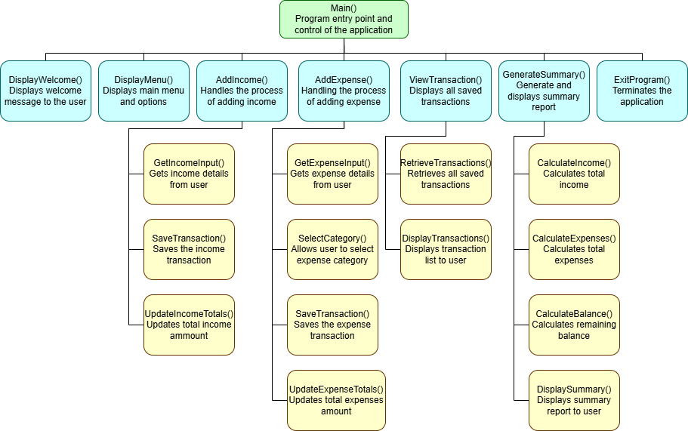

Structure Chart Explanation
The structure chart provides a functional decomposition of the system, identifying the methods and modules that encapsulate key operations.
- Hierarchical Organization: The diagram shows a top-down approach where the Main() method acts as the entry point and controller for the application.
- Encapsulation of Tasks:
  - Input Management: Specialized methods like GetInput() and ValidateData() ensure that user interactions are handled consistently and that only valid data enters the system.
  - Processing Logic: Methods such as CalculateTotals() and CalculateBalance() isolate the mathematical logic from the user interface, improving code readability and maintainability.
  - Data Management: The ManageSystemData() branch highlights how the program retrieves and stores information using the identified data structures.
- Data Structure Integration: As shown in the "Shared Expenses Data Objects" callout, the methods are designed to interact with structured data—specifically a List<Transaction> and a List<string> for categories—to manage shared student expenses effectively.
The Data Structures Used in the System:
The expense-sharing system will make use of dynamic data structures to manage user and transaction information. A List < Transaction> structure will be used to store multiple expense entries that are entered by the users. Lists allow dynamic storage through transaction records during calculations. When a user enters a new expense, it will be added to the list. The list will display all transactions in a menu and is also used in calculations such as the total spending.
A Dictionary<string, double>structure will be used to store the expense categories and in this structure, the category name plays a pivotal role while the total expense amount acts as the value. The use of these data structures helps with improving data organisation and reinforces processing efficiency in the system.

User Interaction

Main Menu Interaction:
The program begins with a user-friendly main menu for the Shared Budget Tracker. Users interact with the system by selecting numbered menu options to perform tasks such as adding income or expenses, viewing transactions and reports, searching records, or exiting the program. For example:
=================================
SHARED BUDGET TRACKER
=================================
1. Add Income
2. Add Expense
3. View Transactions
4. View Monthly Budget Report
5. Exit
=================================
The system then provides step-by-step guidance through clear prompts, confirmation messages after successful actions, and error messages for invalid input. Navigation must be simple and designed to allow users to easily return to the main menu after completing tasks.

Use Case Scenarios:

Case 1: Adding Income
If the user selects “Add Income” the program prompts the user to enter a amount, source and date of the income. The program checks the entered information to ensure that it is correct and complete. Once it is validated, the transaction is then stored in an array, and the total income is then updated. Then lastly the system displays a confirmation message that the income has been added.

Case 2: Adding Expense
If the user selects “Add Expense”, the program to add an expense, the program then displays a list of expense categories like rent, groceries, utilities, entertainment, and transport. The user then enters the expense details, including the amount, category, description, and date. The system validates the information before storing the expense in the database or list. After the expense is successfully recorded, the program updates the category totals and remaining budget. Finally, a confirmation message is displayed to inform the user that the expense has been added successfully.

Case 3: Viewing Transactions
If the user selects “View Transactions”, the program then displays a list of all shared income and expense records, including the date, transaction type, category, and amount. This feature allows students to easily track their financial activities and monitor money that is being spend.

Case 4: Viewing Monthly Report
At the end of the month, students can view a monthly budget report that provides an overview of their financial performance, including total income, total expenses, and the remaining balance. The report also highlights the category with the highest expenses in order to help users better understand their spending habits. This feature enables students to plan future expenses more effectively which improves budgeting decisions and manage their savings efficiently.

Error Handling:
The Budget Tracker program will have various error-handling features to ensure the system operates reliably and effectively. Examples of error handling: Invalid menu selection, incorrect data type input, empty input, negative amount input, incorrect date input. How can the program handle errors like mentioned above. The program can use if statements, switch statements, loops for repeated prompting, try-catch and C# techniques like double.TryParse(), string.IsNullOrWhiteSpace(), DateTime.TryParse(). The program will then provide a feedback message to the user so they will understand what is happening.

HITL
Human-In-The-Loop Programming is a software development approach where users actively participate in decision making of an intelligent system rather than relying entirely on automated AI decisions. In a Budget Tracker system, this means users can review, confirm, or correct AI-generated actions such as categorised expenses, budget suggestions, or transaction deletions. For example, if the system detects a transaction like “R850 at Pick and Pay” and suggests it belongs to the groceries category, the user is prompted to confirm or reject the suggestion, ensuring greater accuracy and control.
This approach improves system reliability by combining human judgment, experience and understanding the context with AI’s pattern recognition, speed and data analysis capabilities. As a result, the system becomes more accurate and user-friendly, while benefiting from both human understanding of context and AI’s ability to process information efficiently.

Future of AI in C#
Artificial Intelligence (AI) is becoming an increasingly important part of modern software development, including applications built with C#. In the future, AI could enhance the Budget Tracker system by introducing features such as automatic expense categorisation, spending predictions, smart budgeting recommendations, fraud detection, voice-controlled input, and AI-powered chat assistants for financial guidance. These improvements would make budgeting tools more intelligent, interactive, and personalised for users.
C# supports the development of AI-driven applications through technologies like ML.NET, Azure AI Services, machine learning libraries, and integration with cloud-based AI systems. For example, an AI feature might alert a user by stating that they spent 25% more on entertainment this month compared to the previous month, helping them make more informed financial decisions.

